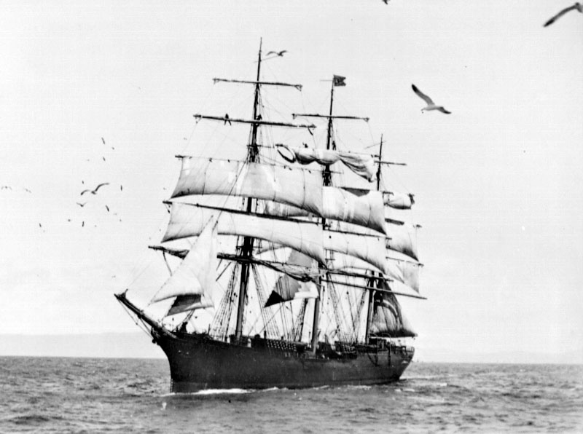

Age of Sail Overnight
Teacher’s Manual
2019

Copyright 2019
San Francisco Maritime National Park Association
All Rights Reserved
Dear Teachers,

Welcome to Age of Sail and thank you for choosing to attend our amazing program! This manual contains everything you need to prepare your class for the Age of Sail overnight program. We update this manual regularly and logistical information may change so please make sure you are using the CURRENT manual by downloading it at maritime.org/edu.
Full link: https://maritime.org/education/overnight-programs/age-of-sail/

One of our most important goals is to help teachers connect classroom content with real-life experience. Math, science, music, literature, language, theatre, visual arts as well as history and social science are all important themes in the Age of Sail program. We continue to work towards building a body of lesson plans and literature that make it easy to develop standards-based instruction that also prepares your students for their voyage. Our website www.maritime.org/edu contains a number of suggested activities and projects which you can use in your classroom if you choose.

If you or any of the parents are interested in hands-on training, we offer monthly “Tall Sailor” (adult chaperone) Workshops from September to May. They are typically held on the first Saturday of each month and provide an excellent opportunity to visit the pier, meet some of the staff and actually participate in program tasks usually reserved for the lads. This is also a great chance to have any questions answered in person. To sign up for a workshop contact our Program Manager Catelyn Kindred at ckindred@maritime.org or call our office at (415) 360-4772.

Additionally, we can arrange for an educator to visit your classroom (in character!) to help prepare your class for their voyage. There is a fee associated with this in-school program, but we strongly recommend this for any teacher new to our program. A small sea chest full of practicing materials can also be rented upon request. For these services please contact Program Manager Catelyn
Kindred at ckindred@maritime.org or call our office at (415) 360-4772.
Finally, I am here as a resource for you as well. Please feel free to contact me if I can be of any assistance prior to your voyage. Thank you for all the hard work that you do and for helping us bring maritime history to life for your students… this is going to be fantastic!

Glenn Howe | Cell: (415) 215-6291
Education Director | Email: ghowe@maritime.org
San Francisco Maritime National Park Association

Table of Contents

Section 1: Introduction to Age of Sail ………………………………………………………….. | 4
Goals | 4
Physical Program Setting | 4
Historical Program Setting | 4
The Characters | 4
Methods | 5
Training | 5
Role of the Participants | 6
Section 2: Setting Up Your Voyage ……………………………………………………………. | 7
Contact Information | 8
Confirming your reservation | 9
Final Payment Information | 9
Cancellation Policy | 9
Dividing your Class into Crews | 10
Tall Sailors | 12
Historian | 12
Guest of the Captain | 13
Sample letter from home | 14
Helpful hints for preparing the crews | 15
Approximate timeline for preparation | 15
Section 3: Voyage Logistics …………………………………………………………………….. | 17
Arrival at the pier | 17
Lunch | 17
Bathrooms | 17
Inclement weather | 17
Check-in | 18
Participant packing list | 19
Food Allergies | 20
Restrictive Diets and Food Detail | 20
Medical and Special Needs | 21
Program Timeline | 22
Medical Form | 23
Liability waiver | 25

Goals
The SF Maritime National Park Association seeks to bring maritime history to life and to support the goals set out in the California Department of Education’s Content Standards. In conjunction with our role as a supporting organization to the National Park, we also seek to preserve and protect our cultural resources through engaging the public and promoting stewardship.

The Age of Sail program was developed to engage students through a challenging and memorable encounter with history, using both the tools of experiential education and the artifacts of the San Francisco Maritime National Historical Park. By living the life of a sailor aboard one of the last surviving examples of a working sail vessel in California, the students will gain a better understanding of local and state history and develop a concept of historical empathy. Both skills are critical to a meaningful understanding and evaluation of the past.

As with a working vessel, the “lads” will need to perform as a disciplined and reliable crew. In immediate and tangible ways, the students learn the value of critical thinking, active listening, problem solving, teamwork, self-respect, self-reliance and leadership.

Physical Program Setting
The Age of Sail program takes place aboard the Balclutha, a 300 ft Square-Rigged Tall Ship that is also a National Historic Landmark Vessel. As such, she is the pride of the Maritime Park and the NPS staff work tirelessly to keep her outfitted and rigged soundly and accurately. Balclutha was built in 1886 in Scotland, meant for the California grain trade. She sailed for 20 years between the UK and San Francisco, making 17 voyages around Cape Horn. She also worked delivering lumber to Australia and as part of the Alaska Packers Association, fishing and canning salmon in Alaska. She has always called on the Port of San Francisco as long as she has been working, and in her we find a rich history of the people and goods that traveled here from locations world-wide. The ship no longer sails and is permanently berthed on the Hyde Street Pier in the SF Maritime National Historical Park.

Historical Setting of the Age of Sail
The year is 1906; there has been a devastating earthquake and fire, and San Francisco lies in smoldering ruins. Much of the population is sheltered in tent cities, and doubts are being expressed about the city’s survival. Balclutha’s regular crew has jumped ship, either to escape the smoldering city, or to fight fires and help in the rescue operations. The Captain, looking to make a quick profit, needs a crew to sail to Oregon for lumber that will be in high demand. The students, or "lads," arrive at Hyde Street Pier to sign aboard as the replacement crew.

Our Captain will not sail with inexperienced green hands, though. The lads must prove to the Captain, through the completion of tasks, that they are capable of sailing the ship. Activities, such as reeving a block and tackle, rigging a Bosun's chair, rowing a longboat, and raising sail are vital to the safe and efficient running of the ship. Under the watchful eye of the Captain, officers work with the “lads” to transform them from green-hands into tarry-handed “salts”.

The Characters
The Captain is master and lord paramount on the ship. As commander on board, he stands no watch, comes and goes when he pleases, is accountable to no one, and is obeyed in every matter without question, even by his chief officer.
The First Mate is in charge of the ship’s operation and is the ranking officer under the captain. He is the chief disciplinarian and expects nothing less than perfection in the work of the crew. The captain tells the first mate what he wishes to have done and leaves it to him to see that his orders are fully carried out. The First Mate is frequently found by the crew to be demanding, loud, and not as socially approachable as the second mate or cook. Devoid of mirth or cheer, his management methods are often based more on intimidation than on diplomacy. He is above all a reasonable man and known for being firm yet fair.
The Second Mate is an experienced sailor who has recently risen from the ranks of a common seaman. He is not, however, the finest example of a sailor, as he is known to be a bit of a scoundrel. He is frequently lazy and prone to vice, but during this crisis the Captain needs able officers, and his sailing skill is unquestionable.
The Doctor is also ship’s cook. He is an old-time sailor who is in charge of all the meals on board, as well as tending to anyone on board who may fall ill. He is uneducated, extremely superstitious and full of sea lore and song, possessing an infectious sense of humor. He is also quite capable in working as a sailor and can swab, splice, mouse, rig, and tar along with the rest.

Methods
The program is run by four professional educators. These staff members are specifically chosen for their skill and experience in using outdoor, hands-on environments to inspire student learning. Using constructivism as a basic philosophy for the program, educators help the students grasp their environment and create their own meaning. Their role is to prompt, guide and encourage the students through each of the challenges they must undertake. We stress the need for the students to rely on their own resources, and to solve difficulties through teamwork and dialogue. Operating under the guidance of the classroom teacher, the staff set age-appropriate levels of difficulty, while maintaining a close observation on the general emotional and physical well-being of the crew.

In addition to constructivism and experiential education theory, the staff uses role play to engage the students and create the desired atmosphere. Each staff member plays a character loosely based on Richard Henry Dana’s book Two Years Before the Mast, modifying necessary elements of the historical setting to match our 1906 scenario. Some of the characters are meant to push the students out of their comfort zone and some are meant to support the students. Through the careful balance of role play and teaching methods, we find that many students make great strides in personal responsibility and awareness in a short period of time.

The adult chaperones, or “Tall Sailors” as they are known on the program, have a vital and unique role to play aboard the ship. They are asked to act as safety observers and to assist the staff in preventing accidents or injury. Each Tall Sailor will be assigned to a crew and will silently follow them around as they work. TALL SAILORS MAY NOT HAVE DIRECT COMMUNICATION WITH THE LADS UNLESS THERE IS AN IMMEDIATE SAFETY CONCERN! Building independence and confidence in the students requires pushing them beyond their comfort zone. With adults deliberately staying silent and, in the background, the students soon forget their presence and begin to take ownership of the program, and responsibility for their own actions.

Training
Apart from some minimum necessary preparation, the amount of training depends on how much the classroom teacher wishes to integrate the program into lesson plans for the year. The projects outlined in this manual are merely a partial list of the ways in which the teacher can introduce lessons on any subject from math and reading, to science and geography (in addition to history) as the “training” that the students must undertake to in order to have a successful voyage.

Our staff can make a program successful even if all that has happened is the bare minimum of preparation. The most important thing is that students (AND PARENTS) have an idea of what is going to happen, that is, that they will be participating in an OUTDOOR, history based, experiential learning program that will be unlike anything else they have ever experienced. There are additional resources available to teachers in the form of in-school visits and teacher/parent workshops.

Roles of the Participants

The Instructors run the program and take responsibility for teaching and guiding the lads. They share the work of looking out for the lads’ safety with the Tall Sailors.

The Students are the sailors. They will be expected to work productively in crews, interact with the ship’s officers, complete their tasks as assigned, and follow all of the ship’s rules. If they break rules or misbehave, they will be assigned “discipline”.

The Tall Sailors are the adult chaperones aboard, silent and self-effacing. They are expected to stay with their assigned crew at all times and speak only when there is an immediate safety concern. The Tall Sailors have one of the most difficult roles on board: they are there for safety only. This is challenging because parents are used to stepping in to help and guide their children in unfamiliar or difficult situations. One of our goals is to increase the problem-solving skills of the children and if a Tall Sailor steps in, the opportunity to learn is lost. It is VITAL that all Tall Sailors are made aware PRIOR TO THE START OF THE PROGRAM that they will not be able to interact with the lads except during an emergency. This can be a very difficult concept for parents to grasp and can be very unsettling for them if they learn it only upon their arrival on the Pier.

The teacher is the Guest of the Captain, observing the lads as they work through the challenges. Like the Tall Sailors, he or she doesn’t interact with the lads once the program begins (unless administering medications) but offers behind-the-scenes guidance to the instructors. As the guest, we ask that you circulate through all the crews and enjoy watching your students grow to meet the challenges of being a sailor.

The Historian is the photographer/videographer for the event, and unobtrusively records the lads’ progress. Like the Tall Sailors, he or she doesn’t interact with the lads once the program begins. The Historian is the ONLY adult who will be taking photographs and, like the Guest of the Captain, should circulate through the crews.

Section 2
Setting Up Your Voyage

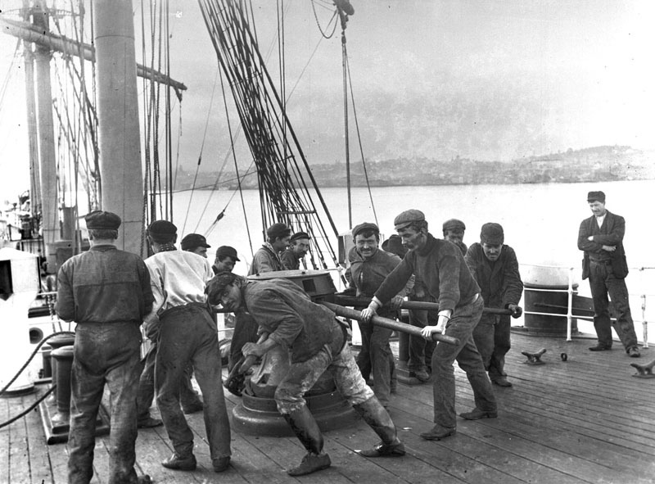
Contact Information:

Age of Sail Program
PO Box 470310
San Francisco, CA 94147
(415) 360-4772

Glenn Howe
Education Director
Cell (415) 215-6291
ghowe@maritime.org

Catelyn Kindred
Program Manager
(415) 360-4772
ckindred@maritime.org

EMERGENCY CONTACT NUMBERS

If you need to reach someone who is on the program, after office hours, for emergency reasons ONLY please call the numbers below. Please state that you are trying to reach someone in the Age of Sail Program at San Francisco Maritime National Historical Park at Hyde Street Pier. They will contact the program staff to call you back. You may only reach a program participant by this method for bona-fide emergencies***

Glenn Howe, Education Director (415) 215-6291
Pier Security: (415) 561-7151
US Park Police Dispatch: (415) 561-5505

*** During the Program the Teachers with cell phones will have them on for emergencies only and can be reached as well.

Confirming your reservation

The month prior to your program, please email the Program Manager, Catelyn Kindred, to confirm the approximate number of participants. This is an excellent time to ask any final questions and to make sure all of your preparations are in place.

Final Payment Information

A deposit will have been paid by this point, and final payment for at least the basic amount of the program should be received in our office at least two weeks prior to the program date. Please mail the check to our P.O. Box (470310) as listed on the contract and be sure to deduct the previously paid deposit. Final adjustments will be taken care of through email/mail afterward your program for any variation in number of participants.

PLEASE PAY FOR YOUR PROGRAM WITH ONLY ONE CHECK. All checks should be made out to “SFMNPA”. If your school has multiple programs, you may either pay with one check to cover all of the programs or pay for each program individually.

Cancellation Policy

When you sign the contract, you are agreeing to our cancellation policy. Please review it carefully.

CANCELLATION AND DATE-CHANGE POLICY:
Changing the date of your program less than 60 days prior to the current program date will incur a $100 date-change fee. Changes with more than 60 days notice will not incur a penalty. Cancellation of a program less than 60 days prior to the program date will hold the school responsible for the full cost of the program minimum ($2,500). Cancellation with more than 60 days notice will not require full payment of the program minimum but will still forfeit the non-refundable $500 deposit. Notice of cancellation must be made and acknowledged in writing.
Dividing your Class into Crews

There are many terms here that will be unfamiliar to novice Age of Sail “Guests” so if this is your first time, just bear with us. There are crew packets that describe the tasks of each crew, as well as many resources to help you understand which elements of preparation are essential, and which are optional. More preparation is not necessarily better, and the students can be over-prepared for the trip. Ultimately, it is up to you (the teacher) to determine how much time you can allot for your students’ preparation, and how to help them have the best experience possible.

Before you come aboard, the class should be divided into five crews: Deckhands, Riggers, Boat, Bosun, and Quartermaster. Details about the activities and duties of each crew can be found online in the “crew packets”. You may wish to assign crews, or they may choose their own crew. Please call us if you have questions regarding crew suitability for students with special needs.

If you have less than 20 or more than 35 students, please call us to discuss crew division. If your group will be larger than 35 students, then an additional “Stevedore Crew”, must be created and an additional instructor assigned. There is a different contract for this size group, maximum number of students is 40.

When you arrive on the pier each crew MUST: (MINIMUM)
· Have a crew mate. The mate is the student “leader” of the crew, responsible for the crew carrying out its tasks and answering to the ship's officers.
· Have a Tall Sailor (adult chaperone).
· Have one labeled container with all their galley gear in it.
· Bring appropriate clothing and sleeping bags.
· Know how to give and receive orders.
· Be familiar with the basic parts of the ship.

Each crew should (if possible):
· Practice 3 - 4 chanteys, one of which is Leave Her, Johnny. Please note that Leave Her, Johnny will only be sung at the very end of the voyage. Students should know at least 1 other chantey they can sing while they work on the ship. Chanteys can be found here, https://tinyurl.com/y5uzrqpe

· Study their assigned tasks and practice skills (detailed information in each crew’s crew packet)

***We realize that there is a tremendous amount of preparation and paperwork for our program. Please know that as long as you have prepared the MUST list, we can create a successful program. We have a small amount of extra gear on board in case things are left at home and are always able to “make it work”.

Boat Crew
Between 5 and 8 students. Working with the second mate, they are responsible for raising and lowering the Dory and rowing the Longboat. Can be a good crew for students who are injured or physically disabled if there are 6 or more students in the crew.

Deckhand Crew
Maximum of 8 students. Working with the first mate, they are responsible for keeping bell time, raising and lowering the ensign (see next page) and setting hawsers.

Bo’sun Crew
Maximum of 8 students. Working with the first mate, they are responsible for keeping bell time, setting hawsers, and taking lead line readings to determine the depth of water.

Rigger Crew
Between five and eight students. Working with the Captain, they are responsible for rigging the bosun’s chair and raising and lowering their fellow crew members in it. At the conclusion of the program the rigger mate will be giving orders to the entire crew.

Quartermaster Crew
Maximum 8 students. This crew works with the ship’s Doctor to swab the deck, set hawsers, ready the stays’l, and/or help bring cargo aboard. Also, a good crew for lads with special needs, as the Doctor character allows for a softer tone.

Stevedore Crew (For crews of 36 to 40)
Minimum of 6, maximum of 8 students. Works with the added staff member, the Bo’sun, to operate a cargo rig and move cargo aboard/ashore.

Ensign
The ensign is the name for an identifying flag in the maritime world. The deckhand crew should prepare the ensign for their class prior to the voyage.

It’s up to the children’s imagination to create the flag’s design, but we ask that there be NO PIRATE MOTIFS. The school or class name and the date are good things to include in the design.

- 24” by 36” is an ideal flag size.
- Non-Absorbent fabric is recommended.
- Remember to reinforce the left side of the flag to handle the Bay winds. Grommets at the upper and lower corners of the left side are recommended. Grommet kits are available at many hardware or fabric stores.
- Acrylic paints and or shapes cut out of felt are ideal in creating the ensigns design.
- Make sure pieces are attached well and the flag is sturdy enough to withstand 15 hours in the SF Bay winds!

It is best for the Teacher or a responsible party to keep it until the lads arrive on the Pier.

Snack
The crew is responsible for bringing a snack to be eaten during the program. Traditional cookies, brownies, and sliced fruit are all good examples of a typical snack. Please bring just 1 snack for everyone, ideally in one container. Do not bring individualized snack for each student, unless one student has special dietary restrictions.

- No Trail mix, jerky, Goldfish, Chex Mix, etc. (as these items tend to get everywhere except into students’ mouths).
- Be sure to read the ingredients of store-bought items and check them against food allergies students may have.
- If you choose to bring fruit, it should arrive cut, peeled and ready to serve.

Tall Sailors

The maximum number of adults, including teachers, allowed to attend our program is eight (8). This allows for five Tall Sailors, one Teacher, one Historian and one aide (if necessary).

Adult Chaperones, or Tall Sailors act ONLY as safety officers for the students. The role we ask them to play and the requirements involved are unusual and challenging, and we strongly recommend that you take some time to prepare them for the voyage. The outdoor nature of the program demands exposure to potentially inclement weather and the ability to stand for long periods of time.

PLEASE NOTE: We do NOT provide foul weather gear for tall sailors. In the event of rain students will be provided with foul weather clothes, however all adult participants should bring their own rain gear.

We ask that you bring one Tall Sailor for each crew. A Tall Sailor may be a parent, guardian or any responsible adult permitted by your school to act in this capacity.

Please bear the following requirements in mind when selecting Tall Sailors for your program.
Ensuring that the Tall Sailor candidates are aware of these requirements and are comfortable with them will help to make the voyage enjoyable for the adults and will keep the program focused on the student’s experience.

1. Tall Sailors do not assist or communicate with the students in any way except to prevent accidents or unsafe behavior. Their vocabulary is limited to a single word “Avast”, which is a warning to the students that they are doing something that may be unsafe. If a Tall Sailor has a concern, they are welcome to ask for assistance from the instructors, by saying “a private word” to the nearest staff member who will handle the issue.

2. Tall Sailors must not be assigned to the same crew as their child. If a child has special needs that require a one on one aide, please contact us to discuss.

3. Tall Sailors must arrive on time and remain on the pier for the entire program.

4. Tall Sailors should be aware that they will be unreachable, except for emergencies, during the program. The teacher will be allowed to keep his/her cell phone for emergencies. Otherwise all cell phones and pagers must be either left at home or stowed in our “contraband” box.

*** Please note that difficult classroom parents will likely be difficult Tall Sailors, unwilling to cooperate with the rules of the Age of Sail program which are vital to the program’s success.

Historian

The historian is the single person responsible for taking all photographs and videos of the voyage. Although the teacher can certainly fulfill this role if need be, we strongly encourage teachers to plan to have another parent along to take care of all the details surrounding the photography. We do this for a number of reasons.

The historian is the designated substitute for adults that fall ill or need to cancel at the last minute. Secondly, the program represents a special time for the teacher to observe his or her class from the outside. Many teachers report gaining valuable new insights into their student’s personalities and learning needs, as they watch them respond to the new and different situation aboard the ship.

Historians are asked to comply with following requests:

- Candid shots of the crew only. No posing or mugging for the camera.
- Flash photography and video camera lights kept to the minimum necessary.
- Ask the “Captain” for permission to leave or board the ship (for safety, authenticity and so the historian doesn’t miss key photo ops).
- No tripods or lighting umbrellas please.

There are power outlets available onboard to charge batteries. Additionally, we are always very grateful to historians who make copies of photographs and videos for us.

Guest of the Captain

The Guest of the Captain is the name given to the classroom teacher or group leader. The Age of Sail program is a unique opportunity for teachers to see their students outside of their usual classroom setting and observe them as an outsider. The Guest follows all of the same rules as the Tall Sailors (not talking to students, saying Avast) but also stays in close communication with the Captain, helping to inform the program instructors. The Guest may wander around from crew to crew at will, but still must ask permission of the Captain before going ashore or returning aboard (just like ALL program participants). As the Guest, the teacher can expect to be responsible for the following:

- Maintaining control of the group before and after the program
- Retaining a cell phone (on vibrate or silent) for emergency purposes
- Handling all student medications during the program
- Consulting with lead instructor (Captain) as necessary regarding individual students

Logbook
Each class should bring a logbook to record their experiences during their night watch rotation. An attractive hardbound blank notebook works well, or your class may decide to make their own.

Sample Letter from Home
Parents are asked to write letters in secret to the students, in the style and manner of people living in 1906. The example letter (on the next page) should be considered as a generic guide. Please do not copy it verbatim! We strongly encourage you to add period detail from your family and community history. The students receive the letters during the Captains dogwatch, and they can be a great comfort to students that are homesick. Sometimes it’s a good idea for the teacher to write a few extra to make sure no one is left out.

May, 1906
Our Dearest Katherine,

How long it has been since we have seen you, dear! You have been away from the family that loves you for so long, it seems like an eternity.

We hope and pray that all is well with you. We had quite a scare from the earthquake and are proud of how you bravely went to sea. How the earth did roll and rumble! Things are fine here, though there is still such a mess to be cleaned up.

The children are all doing well and send their love to their brave and adventurous sister. Daniel Jr. has begun working at the foundry, which has forced him to move into town. The house seems empty without him. He does not seem to mind this change of scenery, for he is quite smitten with Phoebe Cooper and I imagine when he can save the money to buy his own land, he will ask her father for permission to marry her. Matthew is horrified at the idea of having to take over Daniel Jr.'s chores "forever" but is happy to now be the second man of the house.

We do not know how much news you receive of the world; things seem to be getting on well just now. President Roosevelt has proved himself to be a good man to lead our great nation. We are all very excited about the construction of the Panama Canal since brave sailors like you will no longer have to sail around Cape Horn. I know it will take many years to complete. Some say it will not be finished until the year 1914.

I must sign off now. Please do write soon. We can hardly wait to see your smiling face again. We will have a grand celebration upon your homecoming. Fair winds to you, my darling.

Lovingly,

Mother and Father

Helpful Hints for Preparing the Crews
Here some suggestions as to how to motivate the students, and get them excited about the trip:

1. Prior to the voyage, make the mate of each crew responsible for his or her crew in the classroom. Give the work assignments to the mate, then have the mate pass the "orders" to the rest of the crew. Make the mate responsible for collecting and turning in homework and assignments for the entire crew.
2. Have the Deckhand crew make the crew flag (ensign) or make it a class art project. Information on this is in the Deckhand Crew packet.
3. Cover the clock and keep bell time in the classroom.
4. Start a class logbook.
5. Have the entire crew bring their overnight equipment a few days prior to the voyage. This way you can make sure everyone has everything they need. Other classes may be able to supply needed equipment.
6. Have each crew wear matching bandanas or share a crew color. Unfortunately, Balclutha crew shirts are no longer available from the Maritime Store.
7. The crew should make a snack together before the voyage. This will give them experience working as a crew.
8. Prior to the voyage, start incorporating "salty" language (avast, port, starboard, all hands, Sir, carry on) into your everyday vocabulary.
9. To ensure that all students have new experiences, please be careful to avoid gender specific crews, i.e., an all-female Bosun crew or an all-male Boat or Rigger crew.
10. During winter, or rainy weather, have your students put their gear in plastic trash bags labeled with their names.

Approximate Timeline for Preparation (on next page)

This is a guideline; many teachers will not have enough time to take each of the steps listed here during preparation. We understand that your time is precious and that current educational standards are demanding. Just do your best, we’ll take care of the rest

Students | Parents | Teacher
2 months or more before your program
Let the students know about the field trip, get them excited about becoming sailors. Some teachers like to set up their crews months in advance, this is up to you. | Let the parents know about the field trip, send home a note or include it in a newsletter. Request that interested chaperones contact you. | Once deposit and contract are in, read the Teacher’s Manual Calculate costs per student, collaborate with other teachers from your school who are attending.
1 month before your program
Break students into crews and choose mates. You can assign crews or let them choose. Similarly, you can assign mates or have each crew vote for their mate. | Choose “Tall Sailors”, send home parent packet, start collecting money, schedule parent info meetings, Tall Sailor meetings. | Review nautical history, review online lesson plans, consider using one of the books from our reading list during this lead-up time.
2 weeks before your program
Students should have crew assignments. Have students practice vocabulary, chanteys, and bell time. Start ensign project. | Collect medical and liability forms, hold a meeting regarding logistics. Remind parents about letters home, assign deadline for letters. | Look through med forms, buy supplies for ensign, make arrangements for cooking snack. Check with office/PTA/supporting organization about payment.
1 week before your program
Use hierarchy in classroom, call teacher “Captain” or “Sir”, mates are consistently in charge of their crews. Ensign should be close to finished. | Invite parent chaperones into classroom to work with students (if you so please), send second notice to parents about packing list, reminders for parents with children who take medication, final meeting about day-of logistics. | Double check med forms for allergies, dietary restrictions, and other medical issues. Collect parent letters. Confirm transportation, take a deep breath.
2 days before your program
Students are really excited! Have them bring in all of their gear on the packing list. Students with medications should bring them in today! | Suggest that they send their own gear along with students, double check drivers if you are having parents drive. | Gather all the gear in your classroom, each crew should have a labeled container for their galley gear.
1 day before your program
Have mates organize gear, remind them that they need to bring their lunch tomorrow. | Are you missing any parent letters? Forms? Meds? | Make checklist for tomorrow, have a plan for before/after program.
The day of your program
Set the meeting time at least 30 min before you need to load up. Have students stand in crews, mates assist in final head count. | Make sure drivers have copies of directions and parking info, inform parents of final head count | Get to the Hyde Street Pier between 1:45 and 2:00 pm!

Section 3
Voyage Logistics

Arrival at the Pier

Plan to have the bus / drivers drop you off at the corner of Hyde and Jefferson Streets, right next to Victorian Park. You may unload your gear here before the bus leaves / the cars go park. Pile your gear in Victorian park in a central location. Except during inclement weather, you are not permitted to store your gear on the pier or bring your students on to the pier until it is time for your program at 1:45 p.m. Even if you have done this in the past, the Park is no longer permitting us to use the Eureka or other ships as gear storage space unless it is actively raining outside. If you have planned activities before or after the program, arrange to have a chaperone watch the gear while the students are elsewhere.

Lunch (to be eaten before the program)

Participants should bring a bag lunch to be consumed prior to the start of the program. Lunch is eaten in Victorian Park on the benches opposite the restrooms on Jefferson Street. Please dispose of all trash afterwards. If you are sailing on the Explorers program in the morning after the overnight, please bring additional items for lunch the next day. Please do not feed the birds.

If you still have extra time after lunch you can visit the Visitor’s Center, the Musee Mecanique or the USS Pampanito. Additionally, the Maritime Museum is now open. The above attractions are all museum settings, please maintain control of your group at all times.

Bathrooms

The closest bathrooms to Victorian Park are located in the Visitor’s Center on the corner of Jefferson and Hyde streets. We ask that you do not use the bathrooms on the pier until it is time for your program. Please have your adults accompany your students when using the Visitor’s Center bathroom and keep in mind that they are entering a museum environment.

**Inclement Weather Conditions**

IF IT IS RAINING PLEASE CALL US BEFORE YOU UNLOAD SO THAT WE CAN MAKE ARRANGEMENTS FOR YOUR GROUP!

We’ll arrange for you to store your gear in a dry spot and will provide everyone who does not have it with Foul Weather Gear. Before the program starts, it is very important for you to keep all participants and their gear as dry as possible. We advise bringing a couple extra plastic ponchos and lots of large garbage sacks. Please note that we won’t allow ponchos on the ship and will replace them with our foul weather gear.

On the day of the Program the teacher should Check-In @ 1:50 – 2:00 pm:

At 1:45 the group should gather all of their gear and start heading onto the pier. If students need to use the bathroom at this point, you may let them, however a mandatory head call will be the first task that they complete with the Second Mate. Line the crews and Tall Sailors up by the pier railing, in crew lines, directly across the pier from the tug Sea Fox. Bring the following items with you to the Sea Fox to check in:

Final roster of participants by crew (incl. adults﻿)

Completed Medical forms and Liability Releases for ALL participants

Labeled Medications (we can offer storage and want to know about any important meds you will be administering): YOU WILL MANAGE THESE

Logbook

Letters from the parents to lads

Leave the Ensign with the Deckhand Mate!

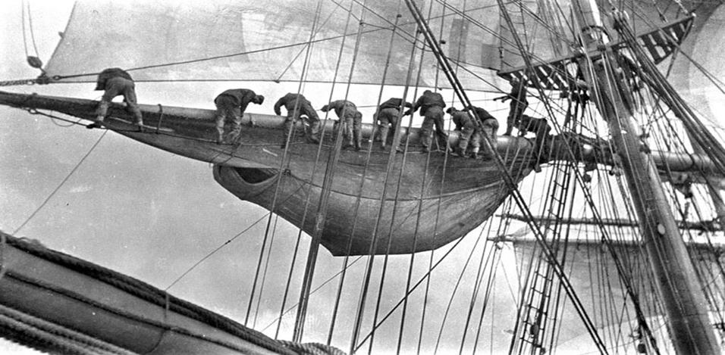

Participant Packing List

1. Warm Clothes
Weather at the Hyde Street Pier is fairly predictable: windy and chilly, and IT WILL ALWAYS BE COLD AT NIGHT! Please ensure that your lads and Tall Sailors are aware of this and pack accordingly. Long pants are required, no shorts or skirts allowed on board. We recommend dressing in layers and bringing a nice warm jacket. Hats and gloves are also recommended although gloves may ONLY be worn on night watch. Long underwear, extra socks, an extra pair of shoes, wool sweaters, and fleece jackets are all good items to bring. It is better to have too many clothes than too few.

4. Footwear
Closed-toed shoes only. Heels and sandals are not allowed and shoes that light up or that have “wheelies” should be left at home. Participants are welcome to wear rubber boots if it is raining.

2. Sleeping Bags
All participants should bring a warm sleeping bag. Students will sleep in the fo’c’sle in wooden bunks where the original crew of the Balclutha lived and slept. Tall Sailors sleep in cabins close to the lads on wooden bunks with additional mattress padding.

3. Foul Weather/Waterproof Gear
Our programs run rain or shine. If it’s rainy we still work outdoors, but if it is extremely rain and cold we will alter activities so the lads and Tall Sailors don’t get too cold.

WE WILL PROVIDE FOUL WEATHER GEAR TO LADS WHO NEED IT! Our gear is not beautiful, but it works and is much better than getting wet. However, if students have “foulies” feel free to pack them. We NOT provide foul weather gear for tall sailors. All adult chaperones should bring their own foulies.

5. Galley Gear

Each participant needs to bring the following eating utensils.

- A cup or mug, a plate, a spoon and a fork are all that is required. These items should be made of metal only and should be durable enough to hold hot stew.
- We recommend a heavy-duty, sturdy pie dish as plate (not the aluminum foil ones), and a metal camping cup as ideal galley gear.
- Each crew’s gear should be collected and organized into one labeled receptacle. Separating each crew’s galley gear into labeled 5 gallon buckets works well.
- Parents are encouraged to label the students eating utensils.

Things to Remember as you are Planning Your Voyage

1. Food Allergies

We are fully aware of the increasing prevalence of food allergies amongst students. We take these allergies seriously, as many of them can be life threatening or extremely debilitating. We are happy to take all the precautions necessary and encourage parents to contact us with special concerns. Special personal food must be ready to eat; no heating available. A good example of a breakfast food is a protein or breakfast bar, if possible. Instant hot cereal packets are also acceptable.

**There are NO NUTS or MEAT in any of the food. There is wheat and gluten in the bread and brownies we serve.

If your student requires an EPI Pen please contact us to discuss the protocol. Depending upon the severity of the allergy we will either have the EPI pen stored onboard or will give it to the student’s Tall Sailor who will be close by at all times if the student is extremely at-risk.

2. Restrictive Diets and Food Detail

Our meals are all vegetarian and our stew is vegan, however if the participant is vegan, dairy or gluten free it is best for them to provide their own clearly labeled brownie (or equivalent) for dinner. Vegan and dairy free students will be served oatmeal and hot cocoa made with water in the morning.

Food Served on our Program:

Snack: Provided by you

Dinner:
Lobscouse Stew: Potatoes, carrots, onions, celery, pinto beans, tomato sauce, salt, pepper, chili powder, garlic powder, basil, oregano

Store-bought Sourdough Bread: enriched bleached wheat flour (wheat flour, malted barley flour, niacin, reduced iron, thiamin mononitrate, riboflavin, folic acid), water, wheat flour, salt, fumaric acid, contains less than 2% of: datem, canola oil, lactic acid, acetic acid, enzyme, l-cysteine, ascorbic acid, and yeast

Brownies Bites: Sugar, Unbleached enriched flour, (wheat flour, malted barley flour, niacin, reduced iron, thiamine mononitrate, riboflavin, folic acid), soybean oil, water, palm oil, cocoa powder (processed with alkali), corn syrup, natural flavor, egg whites, cornstarch, soy lecithin, salt.

Breakfast:
Oatmeal:
Quaker® Oatmeal, Milk (or) Water, Raisins, Brown Sugar, Salt, Cinnamon

Hot Chocolate:
Nesquik, Milk (or) Water

Peaches: Peaches

Nesquik Ingredients: SUGAR, COCOA PROCESSED WITH ALKALI, SOY LECITHIN, CARRAGEENAN, SALT, ARTIFICIAL FLAVORS, SPICE
-Made on equipment that also processes milk, wheat and soy

3. Medical and Special Needs Policies

We never turn students away because of physical, medical or cognitive disabilities. Our goal is to offer a range of activities for such students, and the program supports numerous targets of special education set out by the California Department of Education. We honor all modifications and accommodations provided for in a student’s IEP to the best of our ability, however we cannot provide one-on-one aides. Please let us know in advance of the day of the program if you have any special needs students and we will work with you to accommodate them.

Please bear in mind that the 18-hour program takes place outdoors on a ship and advance communication is key to making the program a success for everyone.

4. Medical Forms and Liability Waivers

Teachers must bring a completed SFMNPA medical form and liability waiver for each participant on the program. Your own school’s field trip permission slips will not be sufficient as we must use our own forms and participation agreements which are vetted by our insurance carrier.

Please review each form personally prior to the voyage. It provides you with an opportunity to become aware of issues that normally don’t affect the student in your classroom but may need our attention on the program. Bedwetting is the most common example of this kind of issue.

5. Medications

WE NO LONGER COLLECT OR ASSSIST IN MANAGING STUDENT MEDICATIONS! We recommend that all student medications be collected by the teacher prior to arrival and clearly labeled in a Ziploc bag with the student’s name and basic instructions. The teacher is responsible for maintaining possession of the medications for the duration of the program. During check-in we will ask about medications so that we understand any potential issues and we will offer you storage. During the program it will be your responsibility to pull students aside and administer their medication.

Program Timeline

Please do not bring your crew on to the pier before 1:45. There are often several other school groups present on the pier, and staff on your program may be working a different program as a different character.
1345-1400 | Assemble students in crew lines, with personal gear in hand, on the left side of the pier across from the Sea Fox office. Please do not pass the ticket booth. Teacher should report to Sea Fox to check in.
1400 | 2nd Mate greets crew, orders Tall Sailors to make a head call and gather at the Sea Fox, guides students through orders and entire crew makes a head call.
1515 | Crew meets the 1st Mate
1540 | Captain greets crew, introduces officers, sets goals, tasks begin
1700 | Coffee ceremony, snack, head call
1900 | Dinner
2115 | Dog watch begins
2200 | Night watch begins, crews not on watch bunk down
0530 | Crew rises
0600 | Breakfast
0730 | Teacher hoist
0800 | Morning dogwatch
0830 | Leave Her Johnny, crew disembarks
0845 | Final head call, gather crew and gear together
0900 | Crew leaves pier, closing gate behind them

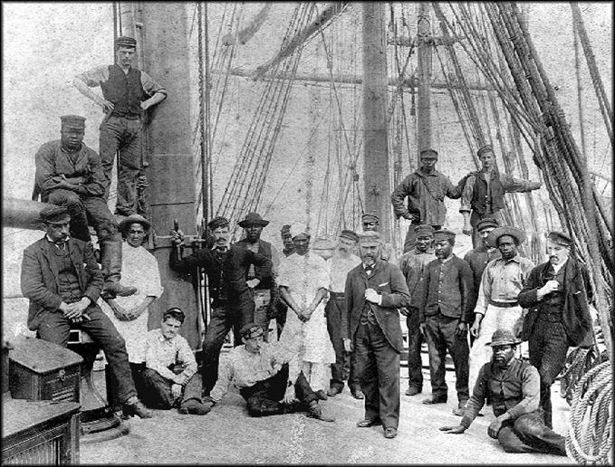
Age of Sail Overnight Program

Participant Emergency Contact Information
 |  |  |  |  |  |  |  |  |  |  | M |  | F
Child’s Name |  |  |  |  |  | Date of Birth |  |  |  |  | Sex
Parent’s/Guardian’s Name |  |  |  |  |  | Parent’s/Guardian’s Name
Home Phone |  |  | Work Phone |  |  | Home Phone |  |  | Work Phone
Address |  |  |  |  |  | Address
City, ST ZIP Code |  |  |  |  |  | City, ST ZIP Code
Alternative Emergency Contact |  |  |  |  |  |  | Insurance Information
Additional Emergency Contact |  |  |  |  |  | Name of Family Physician
Home Phone |  |  | Work Phone |  |  | Physician Phone |  |  | Physician Office/Hospital
Address |  |  |  |  |  | Insurance Provider
City, ST ZIP Code |  |  |  |  |  | Insurance ID # Group #

Medical Information
Is your child currently taking any prescription medications? (list below)*  *If YES please fill out “Administration of Medication” form for EACH medication that will be taken during the program |  |  |  |  |  |  |  |  |  | YES |  | NO
1)
2)
3)
Does your child have any allergies? (list below)……………………………………….. |  |  |  |  |  |  |  |  |  | YES |  | NO
*Does your child have an EPI pen? ……………………………………………. |  |  |  |  |  |  |  |  |  | YES |  | NO
1)
2)
3)
Is your child on a special diet? ………………………………………………………… |  |  |  |  |  |  |  |  |  | YES |  | NO
Explain:
Has your child recently been ill or exposed to communicable disease? ……………….. |  |  |  |  |  |  |  |  |  | YES |  | NO
Is your child subject to Homesickness / Sleepwalking / Bedwetting (circle) ……….. |  |  |  |  |  |  |  |  |  | YES |  | NO
Are there any other issues concerning your child that we should know about? ……….. |  |  |  |  |  |  |  |  |  | YES |  | NO
Explain:
Non-Prescription Medication
In the event of unforeseen circumstances, do you authorize the Age of Sail staff to give your child common remedies such as Children’s Tylenol, cough medicine, etc.?
YES | NO
If you wish for your child to receive non-prescription medications or vitamins, please fill out an “Administration of Medication” form for each medication / supplement.

AUTHORIZATION AND CONSENT FOR STUDENT TREATMENT
1. Parent(s) will be notified immediately when a child becomes injured or seriously ill, and aid will be given according to the Parent(s) wishes. Arrangements will be made with the parent(s) to pick up their child if desired. A child will not be released during the Age of Sail program to anyone other than the parent or guardian except on written or verbal request by the parent or guardian.

2. I/WE, as parent(s) or guardian(s) of _________________________ do hereby authorize the Age of Sail staff, as agents, for the undersigned to consent to any x-ray examination, anesthetic, medical, or surgical diagnosis or treatment and hospital care which is deemed advisable by, and is rendered under the general or specific supervision of any physician and/or surgeon licensed under the provisions of the California Medical or Dental Practice Act on the Medical staff of a licensed hospital, whether such diagnosis or treatment is rendered at the office of said physician or said hospital.

It is understood that this authorization is given in advance of any specific diagnosis, treatment, or hospital care being required but is given to provide authority and power on the part of the aforesaid agents to give specific consent to any and all such diagnosis, treatment, or hospital care which the aforementioned physician in the exercise of his/her best judgment may deem advisable. This authorization is given pursuant to the provisions of section 25.8 of the Civil Code of California. This authorization shall remain in effect until _______(date program ends) unless revoked sooner in writing delivered to said agents.

Signature of Parent(s) or Legal Guardian(s) |  | Date

Please Note:
If you do not wish to grant authorization or consent as outlined above, please sign here and let us know in writing what you want us to do in the event of a medical emergency

Signature of Parent(s) or Legal Guardian(s) _________________________ Date _________
Signature of Parent(s) or Legal Guardian(s) _________________________ Date _________

Program Release
We request that all participants agree to the below provisions and sign below to acknowledge their agreement. A participant without an initialed participation agreement will not be allowed to participate in the program.

A. Participation Agreement
In consideration of myself or my child participating in the programs of the San Francisco Maritime National Park Association, I agree on behalf of myself and my child to assume all risks of injury and to waive all claims, actions, and damages against the Maritime Park Association. I further agree not to sue the Maritime Park Association, its officers, directors, employees, agents or assigns for any claims arising out of participation in the Maritime Park Association’s programs, the actions of the school district or youth group's employees, officers or agents, or the actions of the program participants.
Participant’s Name
Signature of Parent or Legal Guardian |  | Date

B. Photo Release
For the purposes of fund-raising and public awareness, the San Francisco Maritime National Park Association uses photographs and videos of the program in action. These materials may be published in print or made available on our website. Such publications are a very important part of our fundraising efforts. Your child's image may appear in such photos or videos taken by the adult chaperones or our official photographers. We are sensitive to privacy issues, and therefore specific names of participants and their school addresses will not be disclosed.

MEDIA RELEASE: I hereby give permission for San Francisco Maritime National Park Association staff and/or any person acting on their behalf and/or other participants to photograph my child and allow San Francisco Maritime National Park Association to use these pictures in the course of its operations, including publicizing its programs and raising funds. I release all publication rights to said media. (San Francisco Maritime National Park Association will not use student’s names or other identifying information.)

OPT OUT SECTION: To OPT OUT, please check the box below and sign:
☐ I DO NOT give permission Initials: ___________ Date: ____________

C. San Francisco Maritime Opportunities
SF Maritime offers a wide range of programs, events, and opportunities. Would you like to stay connected with us?

Name: _________________ Email: ______________________

